**Assessment of Marginal Workers in Tamil Nadu- A Socioeconomic**

**TEAM MEMBER**

**412621243035:Pooja Sri.M.S**

# Phase-1 Document Submission

**Project definition:** The project involves analysing the demographic characteristics of marginal workers in

Tamil Nadu based on their age, industrial category, and sex. The objective is to perform a socioeconomic

analysis and create visualizations to represent the distribution of marginal workers across different

categories. This project includes defining objectives, designing the analysis approach, selecting appropriate

visualization types, and performing the analysis using Python and data visualization libraries.

**Project Objectives**:

1**. Analyse Marginal Worker Demographics**:

* Gather data on marginal workers, including their age, gender, education level, and employment status.
* Determine the geographic distribution of marginal workers, identifying regions with higher concentrations.
* Assess the reasons for marginal employment, such as underemployment or seasonal work.

2. **Understand Age and Gender Distribution**:

* Examine the age distribution among marginal workers to identify trends and potential vulnerabilities.
* Analyze the gender distribution to uncover any disparities or gender-specific challenges faced by marginal workers.
* Explore how age and gender intersect to impact marginal employment.

3. **Explore Industrial Categories**:

* Categorize marginal employment by industry sectors, such as agriculture, manufacturing, or services.
* Investigate the types of jobs held by marginal workers within these sectors.
* Determine the prevalence of informal or unregulated work in various industries.

4.**Identify Socioeconomic Factors**

* Investigate socioeconomic factors that contribute to marginal employment, including income levels, education, and access to social services.- Explore the impact of rural vs. urban environments on marginal employment. Analyze the relationship between marginal employment and poverty rates.

5. **Assess Policy Implications:**

* Evaluate existing labor policies and social safety nets to determine their effectiveness in addressing marginal employment.
* Recommend policy changes or interventions to improve the livelihoods of marginal workers.
* Examine the role of government initiatives, NGOs, and community organizations in supporting marginal workers.

6. **Predict Future Trends:**

* Use historical data and demographic trends to make projections about the future of marginal employment.
* Anticipate how factors like automation, economic shifts, and changes in labor markets may affect marginal workers.
* Develop strategies to adapt to future challenges and opportunities in the labor force.

7. **Provide Actionable Insights:**

* Summarize findings in a way that informs policymakers, researchers, and organizations about the current state of marginal employment.
* Offer actionable recommendations to address the identified issues and improve the conditions of marginal workers.
* Encourage data-driven decision-making and advocacy for marginalized labor force segments.

By achieving these objectives, the project aims to gain a comprehensive understanding of marginal employment, its underlying demographics, and the factors influencing it, ultimately contributing to the development of policies and interventions that promote economic stability and social equity.

**Analysis Approach**:

Analyzing socioeconomic data involves a series of steps, from data acquisition and cleaning to exploration and interpretation. Here's a structured approach to plan your analysis:

**1. Define Objectives and Research Questions:**

* Clearly state your research objectives and questions. What do you want to learn or discover from the socioeconomic data?

**2. Data Collection:**

* Gather relevant socioeconomic data from trusted sources such as government databases, surveys, or academic research. Ensure the data aligns with your research objectives.

**3. Data Cleaning and Preprocessing:**

* Clean the dataset to remove errors, missing values, and inconsistencies. Common tasks include:

- Handling missing data (imputation or removal).

- Standardizing variable names.

- Encoding categorical variables.

- Detecting and handling outliers.

- Normalizing or scaling data if necessary.

- Addressing data quality issues.

**4. Exploratory Data Analysis (EDA):**

* Explore the dataset to gain a preliminary understanding of its characteristics. Key EDA tasks include:
* Descriptive statistics: Calculate summary statistics.
* Data visualization: Create plots and charts to visualize distributions and relationships.
* Identify patterns, trends, and correlations.
* Hypothesis generation: Formulate initial hypotheses for testing.

**5. Hypothesis Testing and Statistical Analysis:**

* Test hypotheses derived from your EDA to draw meaningful conclusions. This step may involve various statistical techniques depending on your research questions, such as t-tests, ANOVA, regression analysis, or chi-square tests.

**6. Advanced Data Analysis:**

* Depending on the complexity of your research, consider more advanced analyses like:
* Multivariate analysis: Examining interactions between multiple variables.
* Time series analysis: If dealing with temporal data.
* Cluster analysis: Grouping similar observations together.
* Predictive modeling: Building models to forecast or predict socioeconomic outcomes.

**7. Data Visualization for Insights:**

* Create compelling data visualizations to communicate your findings effectively. This can include the visualization types mentioned in the previous response, tailored to your specific insights.

**8. Interpretation and Insights:**

* Interpret the results of your analysis in the context of your research questions. Identify key insights, patterns, and relationships in the data.

**9. Policy or Strategy Recommendations:**

* If your analysis is intended to inform policy decisions or business strategies, provide recommendations based on your findings. Discuss the implications of your results.

**10. Report or Presentation:**

* Communicate your analysis and findings through a report or presentation. Ensure your audience can understand the results and their significance.

**11. Peer Review and Validation:**

* If possible, seek peer review or validation of your analysis from experts in the field to ensure the quality and credibility of your work.

**12. Ethical Considerations:**

* Consider ethical issues related to the data, especially when dealing with sensitive socioeconomic information. Ensure data privacy and comply with ethical guidelines and regulations.

**13. Iteration and Further Analysis:**

* Be open to refining your analysis or conducting further investigations based on feedback, new data, or evolving research questions.

**14. Documentation and Reproducibility:**

* Document your analysis process, data sources, and code to ensure reproducibility and transparency.

Remember that the specific steps and techniques you use may vary depending on the nature of the socioeconomic data and your research objectives. Flexibility and adaptability are important in the analysis process.

**Visualization Selection:-**

Selecting suitable visualization types for representing demographic distributions effectively in socioeconomic analysis is crucial for conveying insights clearly and accurately. The choice of visualization depends on the nature of your data and the specific aspects of demographic distributions you want to highlight. Here are some visualization types that work well for this purpose:

**1. Bar Charts:**

* Grouped Bar Charts: Use these to compare the distribution of a demographic variable across different categories, such as income levels, education levels, or age groups.
* Stacked Bar Charts: These are effective for showing the composition of a demographic variable within a single category. For example, you can use them to display the distribution of ethnicities within a particular region.

**2. Histograms:**

* Histograms are useful for visualizing the distribution of a continuous demographic variable, such as income or age. They help in identifying patterns and trends within the data.

**3. Box Plot:**

* Box plots are valuable for displaying the distribution, central tendency, and variability of a demographic variable. They are particularly helpful when comparing distributions across different demographic groups.

4. Density Plots:

* Density plots provide a smooth representation of the distribution of a variable, allowing you to see the shape and characteristics of the distribution more clearly, especially for continuous variables.

5.Population Pyramids:

* Population pyramids are specifically designed to show the age and gender distribution within a population. They are helpful for analyzing demographic changes over time.

6. Choropleth Maps:

* If your socioeconomic data is geographically distributed, choropleth maps can be used to represent demographic distributions across regions or areas. Color intensity can be used to highlight variations.

**7. Heatmaps:**

* Heatmaps can be useful for displaying relationships between two categorical demographic variables. You can use color intensity to represent the strength of associations.

**8. Scatter Plots:**

* Scatter plots are effective for exploring relationships between two continuous demographic variables. They can help identify correlations or trends.

**9. Treemaps:**

* Treemaps are useful when you want to represent hierarchical demographic data, such as the distribution of income levels within different regions and subregions.

**10. Sankey Diagrams:**

* Sankey diagrams are suitable for visualizing the flow or transitions between demographic categories, such as educational attainment leading to employment status.

**11. Line Charts:**

* Line charts can be used to track changes in demographic distributions over time, such as income trends or educational attainment over the years.

**12. Radar Charts:**

* Radar charts can be employed when you want to compare multiple demographic variables across different categories simultaneously, showing patterns and differences.

When selecting a visualization type, consider the audience's familiarity with the chosen chart and ensure that the visualization effectively communicates the insights you want to convey. Additionally, always label your visualizations appropriately and provide context to aid interpretation.

**Project Code:**

import pandas as pd

import numpy as np

import matplotlib.pyplot as plt

import seaborn as sns

df=pd.read_csv("ds.csv")

df.plot()

print(f'no of columns={df.shape[1]}')

print(f'no of rows = {df.shape[0]}')

df.describe()

df.info()

males_col=[i for i in df.columns if 'Males' in i]

females_col=[i for i in df.columns if 'Females' in i]

print("----MALES----")

for i in males_col:

print(i)

print("----FEMALES----")

for i in females_col:

print(i)

print('-------CO-RELATION--------')

sns.heatmap(df.corr(), cmap="YlGnBu", annot=True)

plt.gcf().set_size_inches(9, 8)

plt.show ()

print("---male contibution---")

sns.heatmap(df[males_col].corr(), cmap="YlGnBu", annot=True)

print("---female contibution---")

sns.heatmap(df[females_col].corr(), cmap="YlGnBu", annot=True)

age_groups=df['Age group']

age_group=list(age_groups.unique()[1:-1])

age_count=list(age_groups.value_counts()[1:-1])

plt.bar(age_group,age_count)

plt.show()

**Output:**

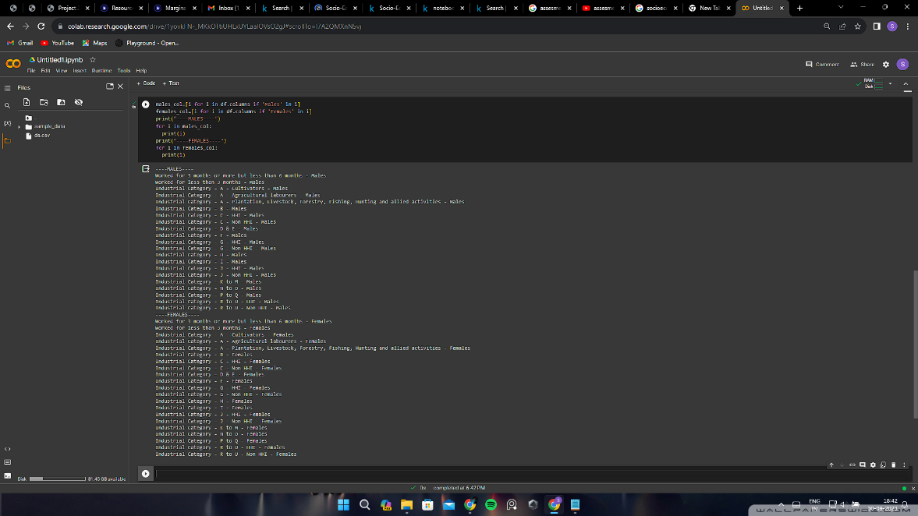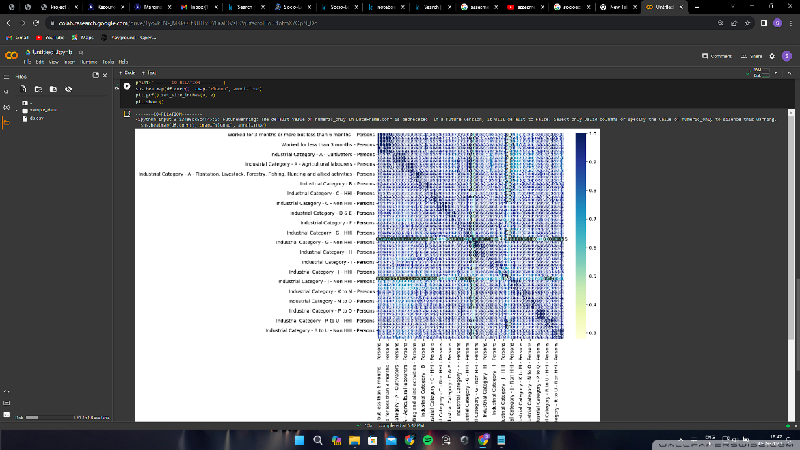

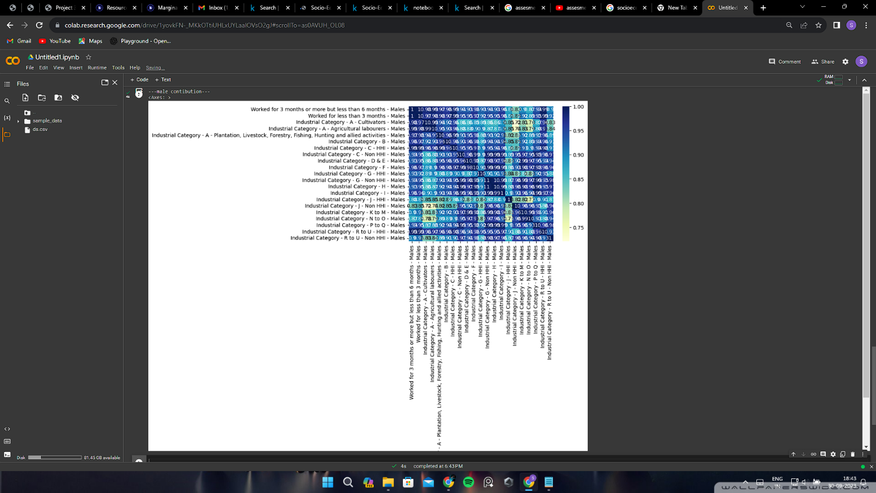

**CONCLUSION:**

In Phase 1, we have established a clear understanding of our goal: to predict Air quality analysis using Visualization techniques. We outlined a structured approach that includes the steps to load, preprocess, analyze, and visualize the air quality and we also done the data.Visualization using visualization techniques (e.g., line charts, heatmaps) to effectively represent air quality trends and pollution levels.